European Day of Languages Quiz 2025 Form
Languages are powerful tools that connect people, cultures, and ideas. Learning another language helps us understand the world, appreciate diversity, and build friendships across borders. The European Day of Languages celebrates the rich variety of languages spoken across Europe and reminds us how important it is to preserve and learn them. The EU has 24 official languages: Bulgarian, Croatian, Czech, Danish, Dutch, English, Estonian, Finnish, French, German, Greek, Hungarian, Irish, Italian, Latvian, Lithuanian, Maltese, Polish, Portuguese, Romanian, Slovak, Slovenian, Spanish, and Swedish. Let’s do a fun quiz to familiarise ourselves with some of these languages. Return to the MFL department by Friday 26th September
Round 1: Guess the Language (Sound files) Your teacher will play the sound file and you need to guess the European language being spoken.
1.
2.
3.
4.
5.
Round 2: Anagrams. Guess the European language
6. ANVIL AT
7. A MAN IRON
8. HAD SIN
9. GO UPSET RUE
10. BARE SIN
Round 3: Write the name of the country and the main language spoken in that country
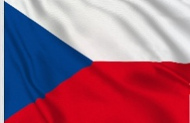
1. Country ________________________ Language ________________________

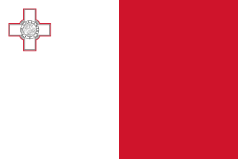
2. Country ________________________ Language ________________________
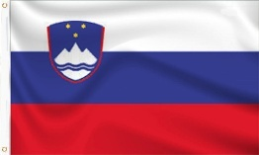
3. Country ________________________ Language ________________________
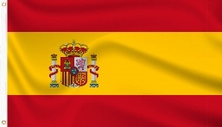
4. Country ________________________ Language ________________________

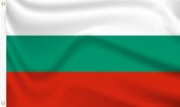
5. Country ________________________ Language ________________________

